*Florida International University*

*School of Computing and Information Sciences*

Software Engineering Focus

Feature Document

User Story ID <788>

**Name: Carlos Martinez**

**Team Member(s):**

Mairim Barrios - Arelys Alvarez - Carlos Martinez - Samira Tellez - Fidel Hernandez

**Project:**

AR-VR-VE for Computer Science

**Product Owner(s)**:

Dr. Francisco Orega

**Mentor(s)**:

**Instructor**:

Masoud Sadjadi

**User Story Name: Pause Menu**

* Description: **As a user I would like there to be a pause menu so that I can take a break from the game whenever I desire**

Acceptance Criteria

* Button pauses game
* Can exit game pressing quit button
* Can return to game pressing either ‘resume game’ or with a button from the keyboard.

**Use Case**

* Name: User enters game
* Actor: Player
* Preconditions: User has entered pressed pause button
* Description <The player has begun the game and would like to pause it.>:

**Use Case Diagram**

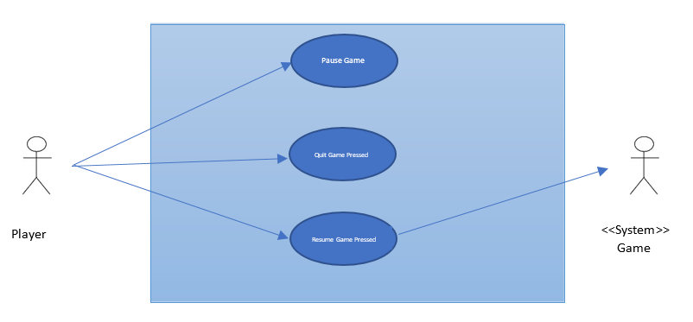

**Sequence Diagram**

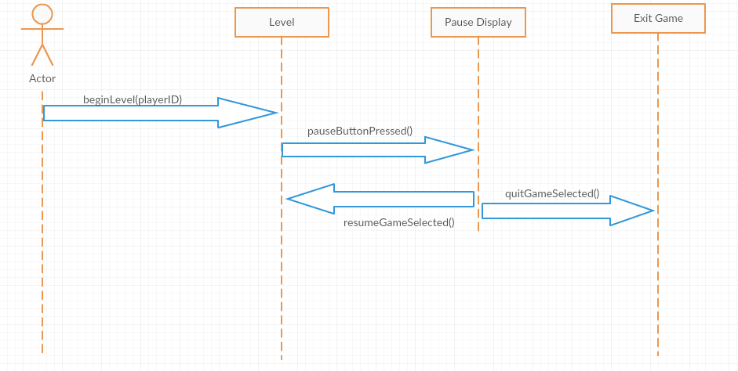

**Class Diagram**

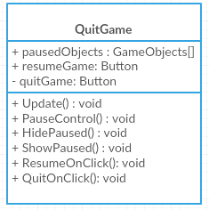

User Story ID <789>

**Name: Carlos Martinez**

**Team Member(s):**

Mairim Barrios - Arelys Alvarez - Carlos Martinez - Samira Tellez - Fidel Hernandez

**Project:**

AR-VR-VE for Computer Science

**Product Owner(s)**:

Dr. Francisco Orega

**Mentor(s)**:

**Instructor**:

Masoud Sadjadi

**User Story Name: Basic Character Movement**

* Description: **As a user I would like to move my character in the basic cardinal directions so that I could properly play the game**

Acceptance Criteria

* Basic up,down,left,right commands work properly
* Character moves accordingly/smootlhly to commands

**Use Case**

* Name: User enters game
* Actor: Player
* Preconditions: User has entered a movement command
* Description <The player has begun the game and moves their player by inputting a movement command.>:

**Use Case Diagram**

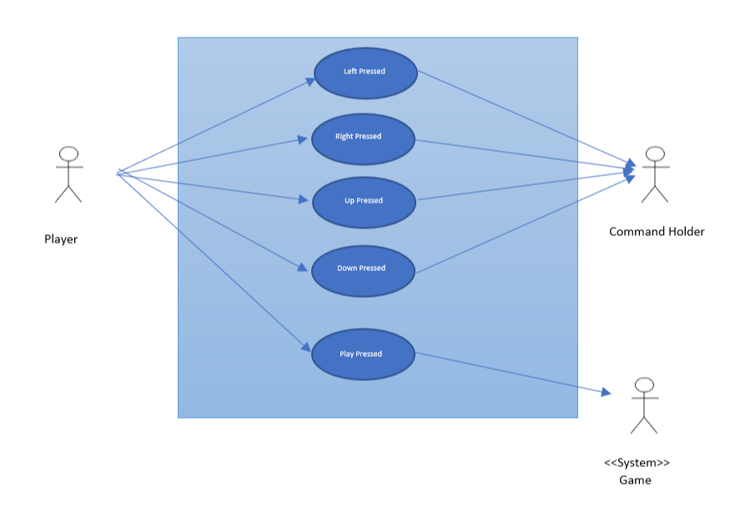

**Sequence Diagram**

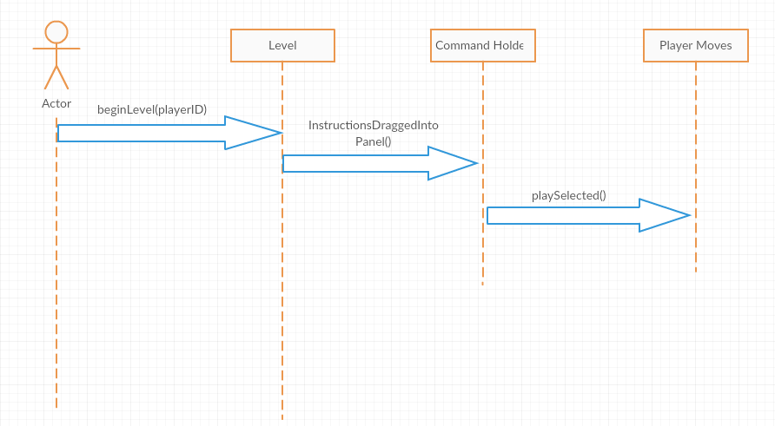

**Class Diagram**

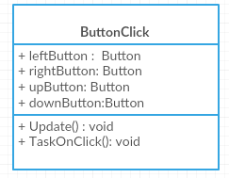

User Story ID <790>

**Name: Carlos Martinez**

**Team Member(s):**

Mairim Barrios - Arelys Alvarez - Carlos Martinez - Samira Tellez - Fidel Hernandez

**Project:**

AR-VR-VE for Computer Science

**Product Owner(s)**:

Dr. Francisco Orega

**Mentor(s)**:

**Instructor**:

Masoud Sadjadi

**User Story Name: Loop**

* Description: **As a user I would like there to be a way for I can put my commands in a loop so that I can use less commands to reach the end of the level**

Acceptance Criteria

* Basic commands working along side the loop
* Basic commands work in the loop and get done multiple times

**Use Case**

* Name: User plays game
* Actor: Player
* Preconditions: User has entered a movement command with a loop command in it
* Description <The player has begun the game and moves their player by inputting a movement command combined with a loop command.>:

**Use Case Diagram**

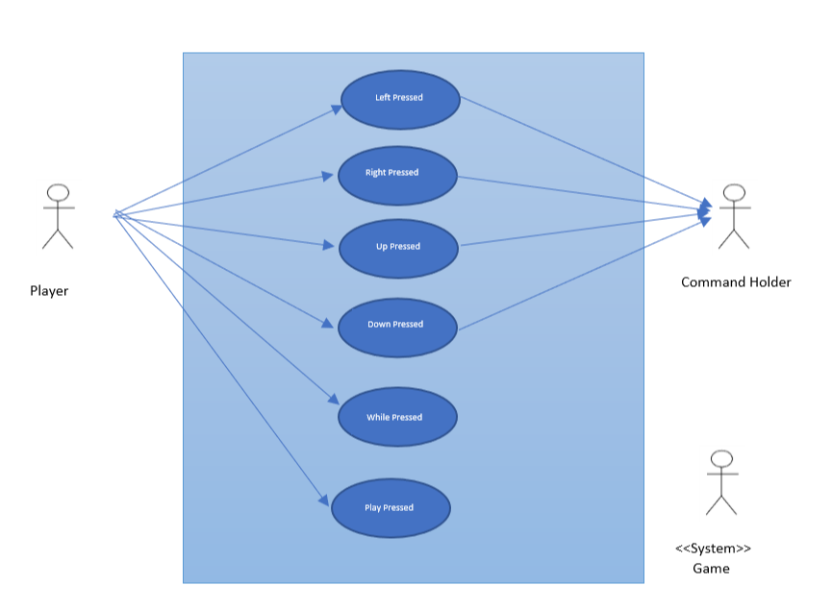

**Actor exists outside the boundaries of the system that is being modelled, actors command holder and system Game should be modelled as classes in the class diagram, not as actors.**

**Sequence Diagram**



**Class Diagram**

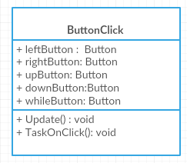

User Story ID <791>

**Name: Carlos Martinez**

**Team Member(s):**

Mairim Barrios - Arelys Alvarez - Carlos Martinez - Samira Tellez - Fidel Hernandez

**Project:**

AR-VR-VE for Computer Science

**Product Owner(s)**:

Dr. Francisco Orega

**Mentor(s)**:

**Instructor**:

Masoud Sadjadi

**User Story Name: Multiple Loop**

* Description: **As a user I would like to be able to issue multiple while loop commands so if I need to use more than one while loop to solve a problem I can do so with ease.**

Acceptance Criteria

* Multiple while loops in one series of commands
* Each loop is able to perform a different series of commands.

**Use Case**

* Name: User plays game
* Actor: Player
* Preconditions: User has entered a movement command with multiple loop commands in it
* Description <The player has begun the game and moves their player by inputting a movement command combined with multiple different loop commands.>:

**Use Case Diagram**



**Sequence Diagram**



**Class Diagram**

